CLOUD COMPUTING LAB: WEEK 3

PES1201802127

Siddharth K Rao

1. Create Virtual Private Cloud Network, create subnets across availability zones, understand connectivity within and between subnets. Understanding NAT, ACLs and Routing Tables.
   1. Create an Elastic IP Address: 3a

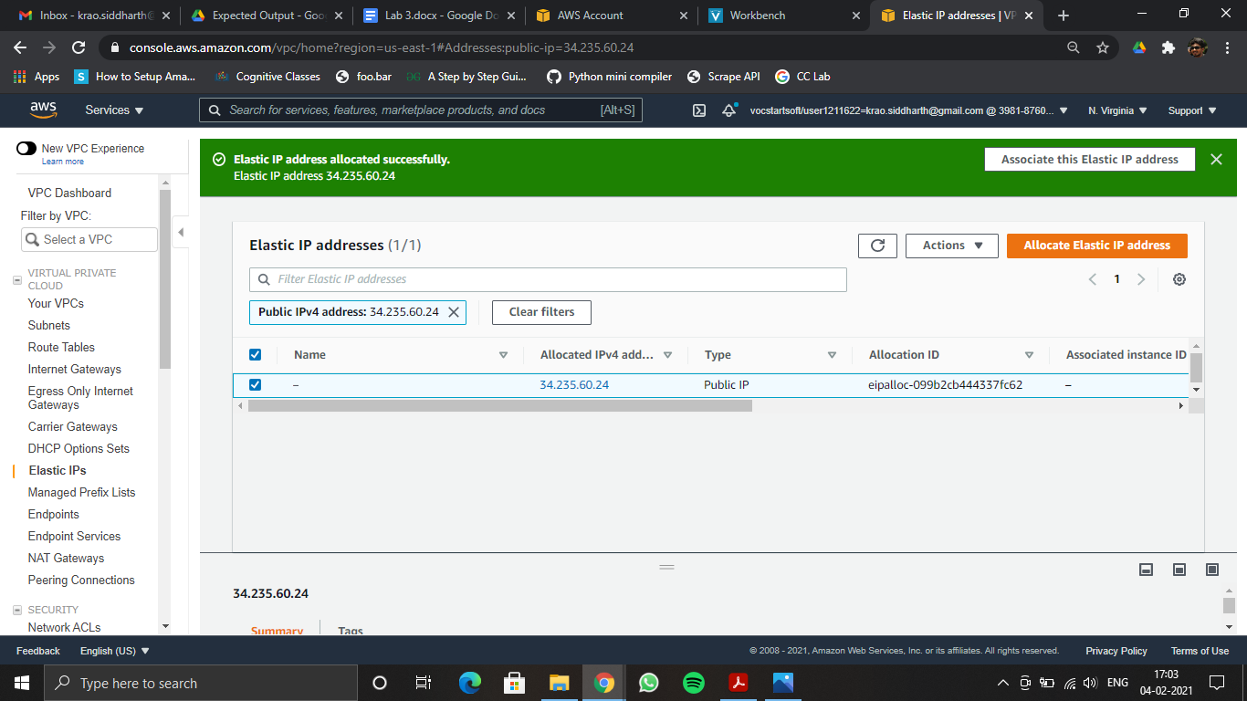

* 1. Create a VPC: 3b

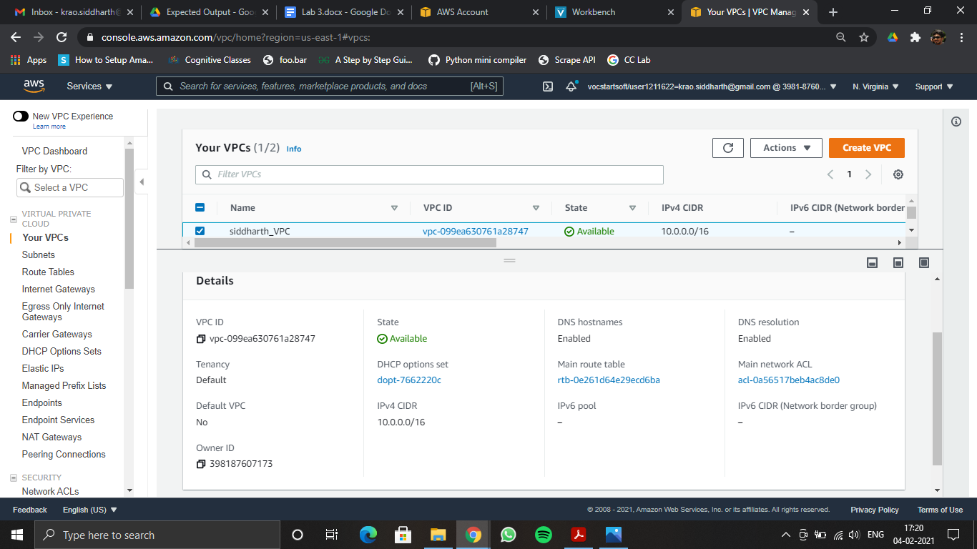

3c: Subnet Details

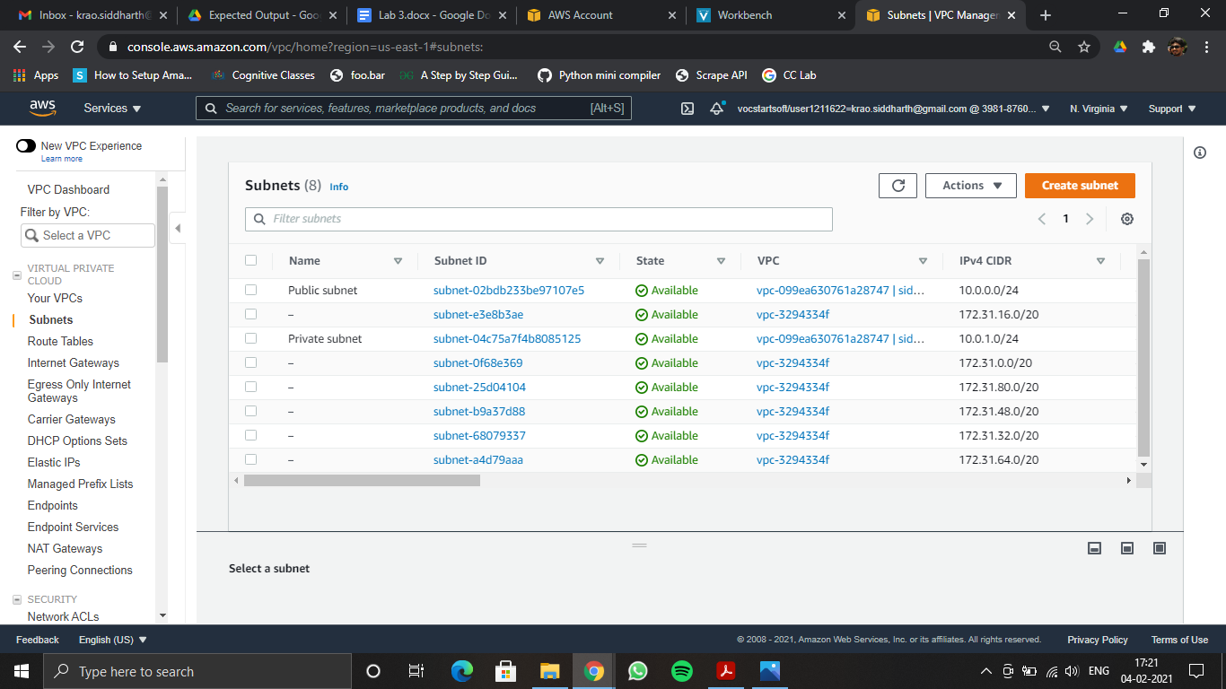

3d: Public Network Details

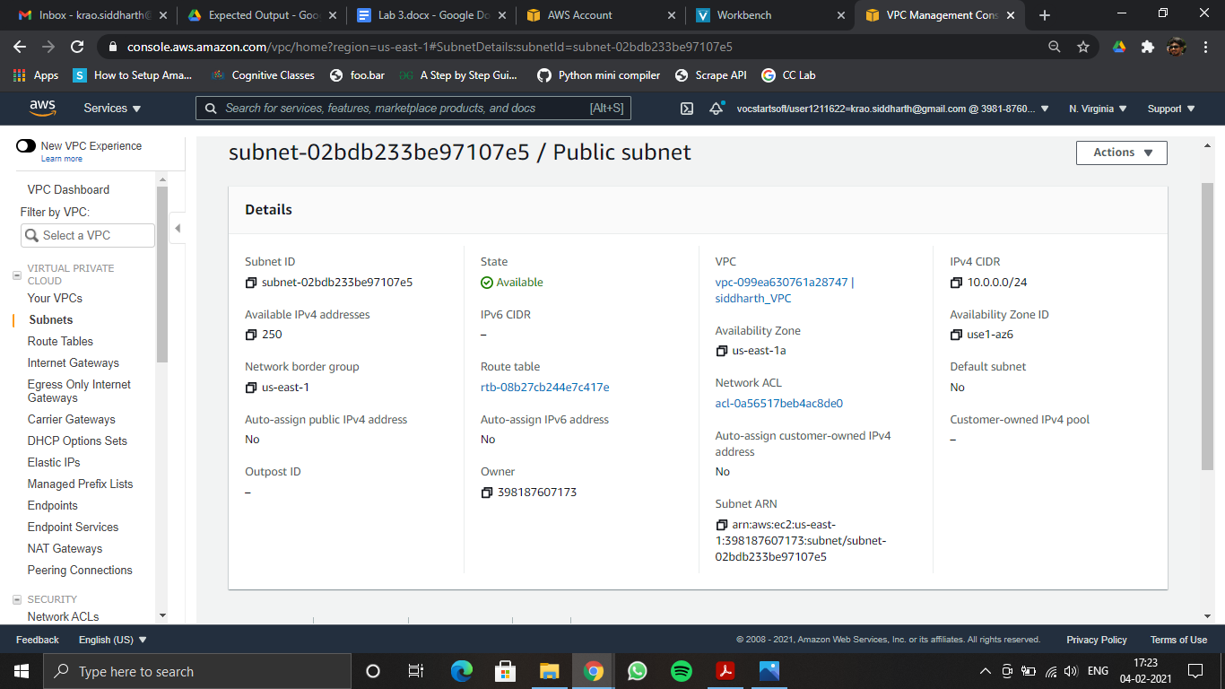

3e: Inbound Rules Change

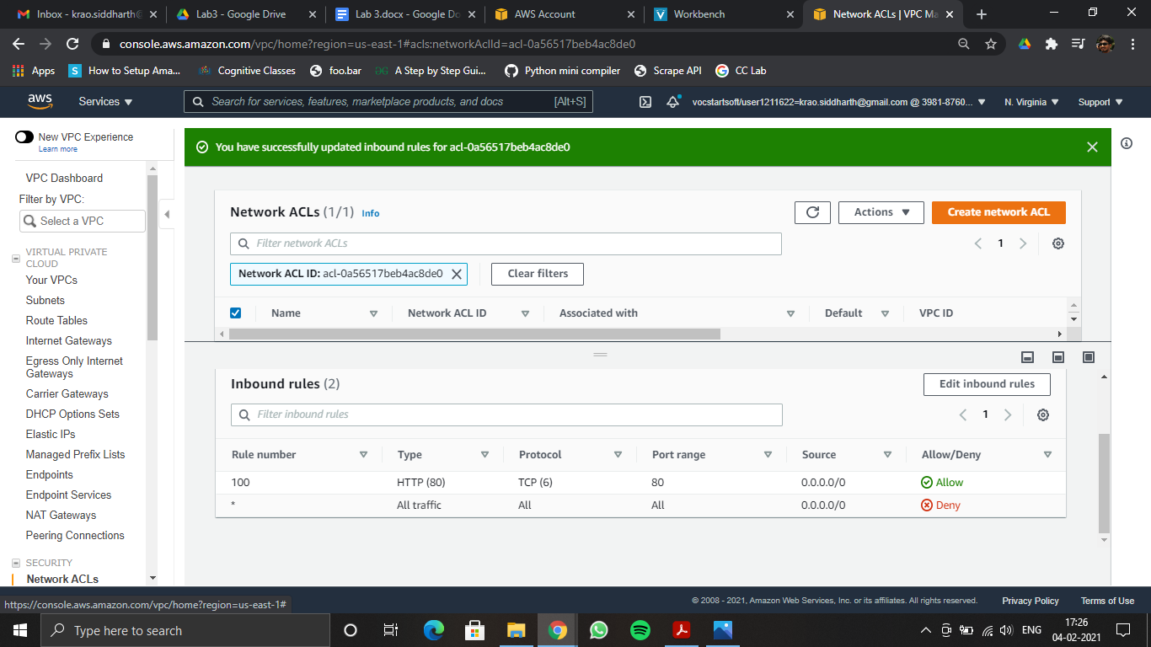

1. Migrate application developed earlier on elastic beanstalk to VPC. Use both public and private cloud (Hybrid Cloud): Load balancer in the public cloud and the application along with the database resides in the private cloud. Migrating your existing application on Beanstalk into the VPC.

3f:

